**Underwater Camera Manual**Before deployment:

* **Familiarise with hardware** – read project report and identify the main controllers:   
  Green board with camera – Raspberry Pi.  
  Blue board with GPS – Arduino.
* **Check battery charge** – charge batteries until charging circuit LED indicator light is solid red.   
  Check battery voltage using voltmeter to ensure healthy state of charge. Between 4 to 4.2 volts indicates charges state, 3.6v indicates discharge, 3v is absolute minimum of the batteries. Fully charging the battery bank may require a full day.
* **Test run –** perform a ‘dry’ test using small recording interval. Make sure system performed well and output files were created. If any issues arise, **turtle.log** file can help troubleshooting.

Deployment:

1. **Set system parameters** - Insert USB flash drive into a computer and open **mission.txt** file.   
   In the file you will find parameters for system operation such as, recording interval, video parameters, GPS interval and more. Edit the file, while maintaining the correct format.  
   **“start”** and **“end”** – indicates beginning of video recording during each day of deployment.   
   Notes:

* Start and end time are in 24-hour format in Atlantic Time zone (Nova Scotia UTC-3).
* Before changing parameters other than mission timing, perform a ‘dry’ test.
* To avoid file corruption, USB should only be removed when Camera controller (Raspberry Pi) is turned off, or in shutdown state (Green LED Is not blinking while red stays solid).
* If file is deleted or moved the system will operate under default parameters.
* Save and close the file after editing

1. **Turn Switch into OFF position**

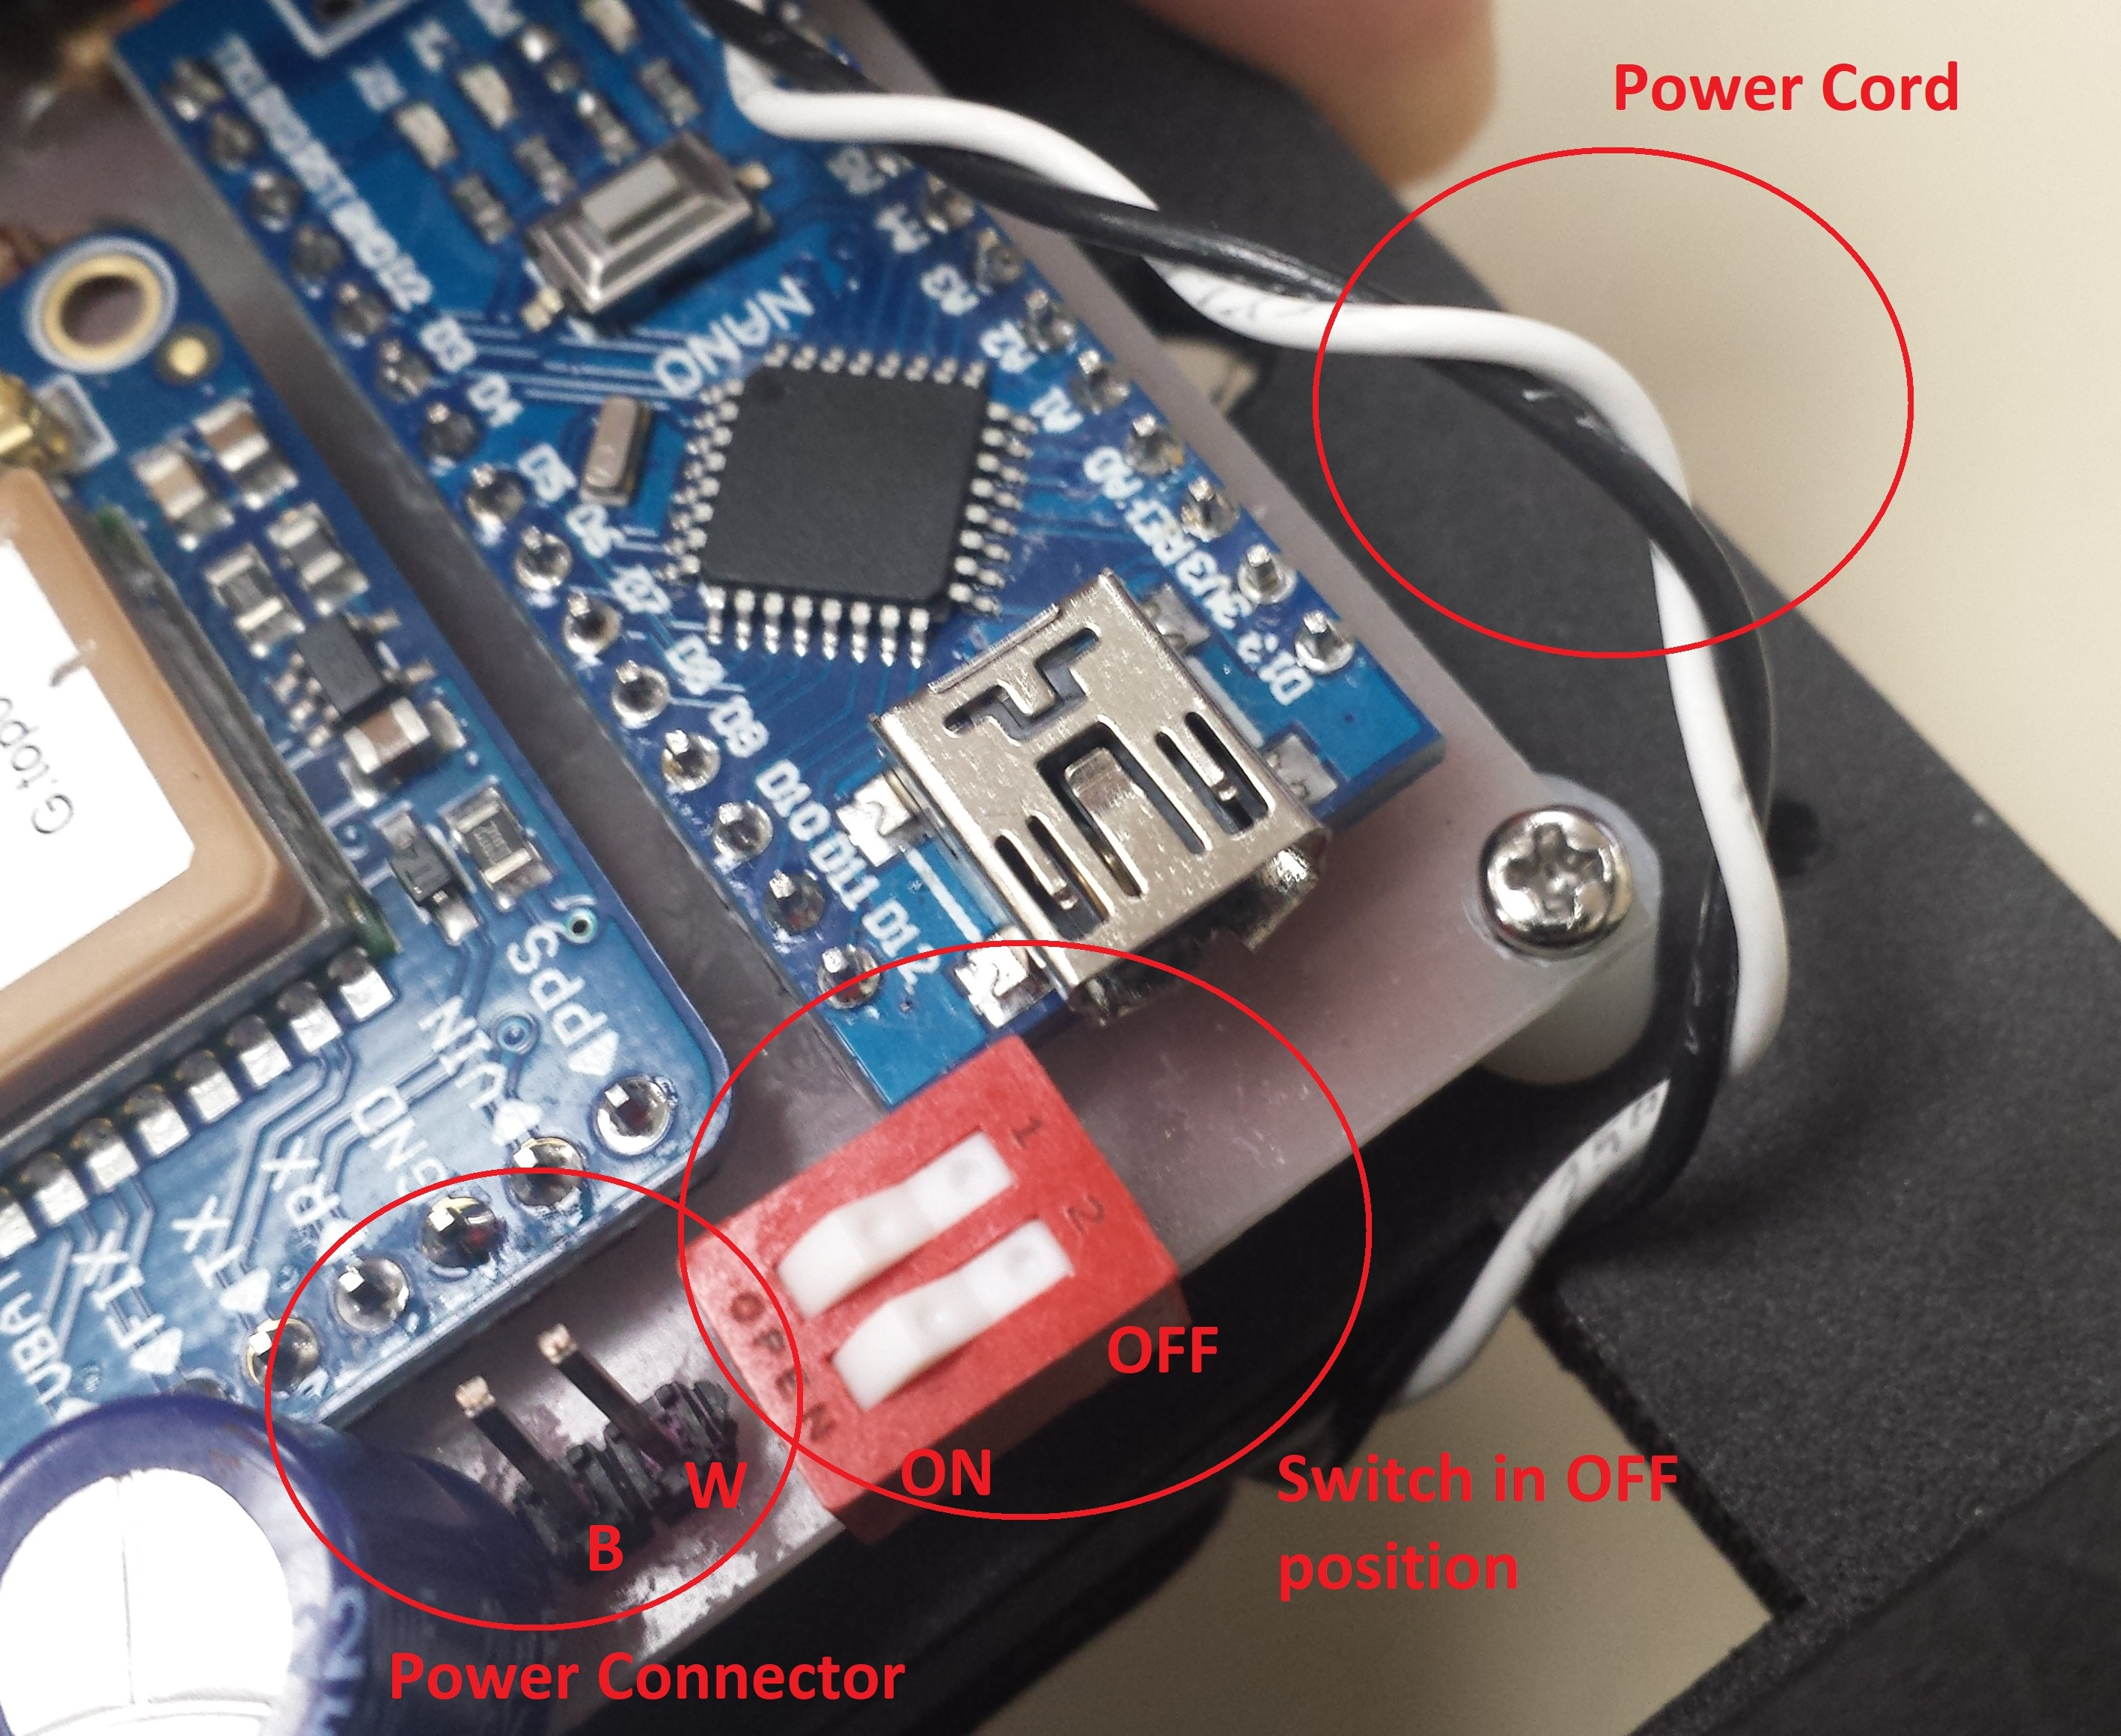

1. **Connect Power** – User a two wire connector - White and Black from battery charging circuit to supply power to the system. White – Positive, Black – Negative. In the image above, white wire connection is labeled **w** and it faces the red switch.
2. **Connect USB flash drive** – use available USB port on the Raspberry Pi to connect the USB drive with mission file.
3. **Verify Switch Operation** – turn switch into ON (labeled **Open** on the switch) and OFF position quickly a few time and observe the LED indicator on Blue Timing board (Arduino) change. After switch operation is verified, leave the switch in **ON** position

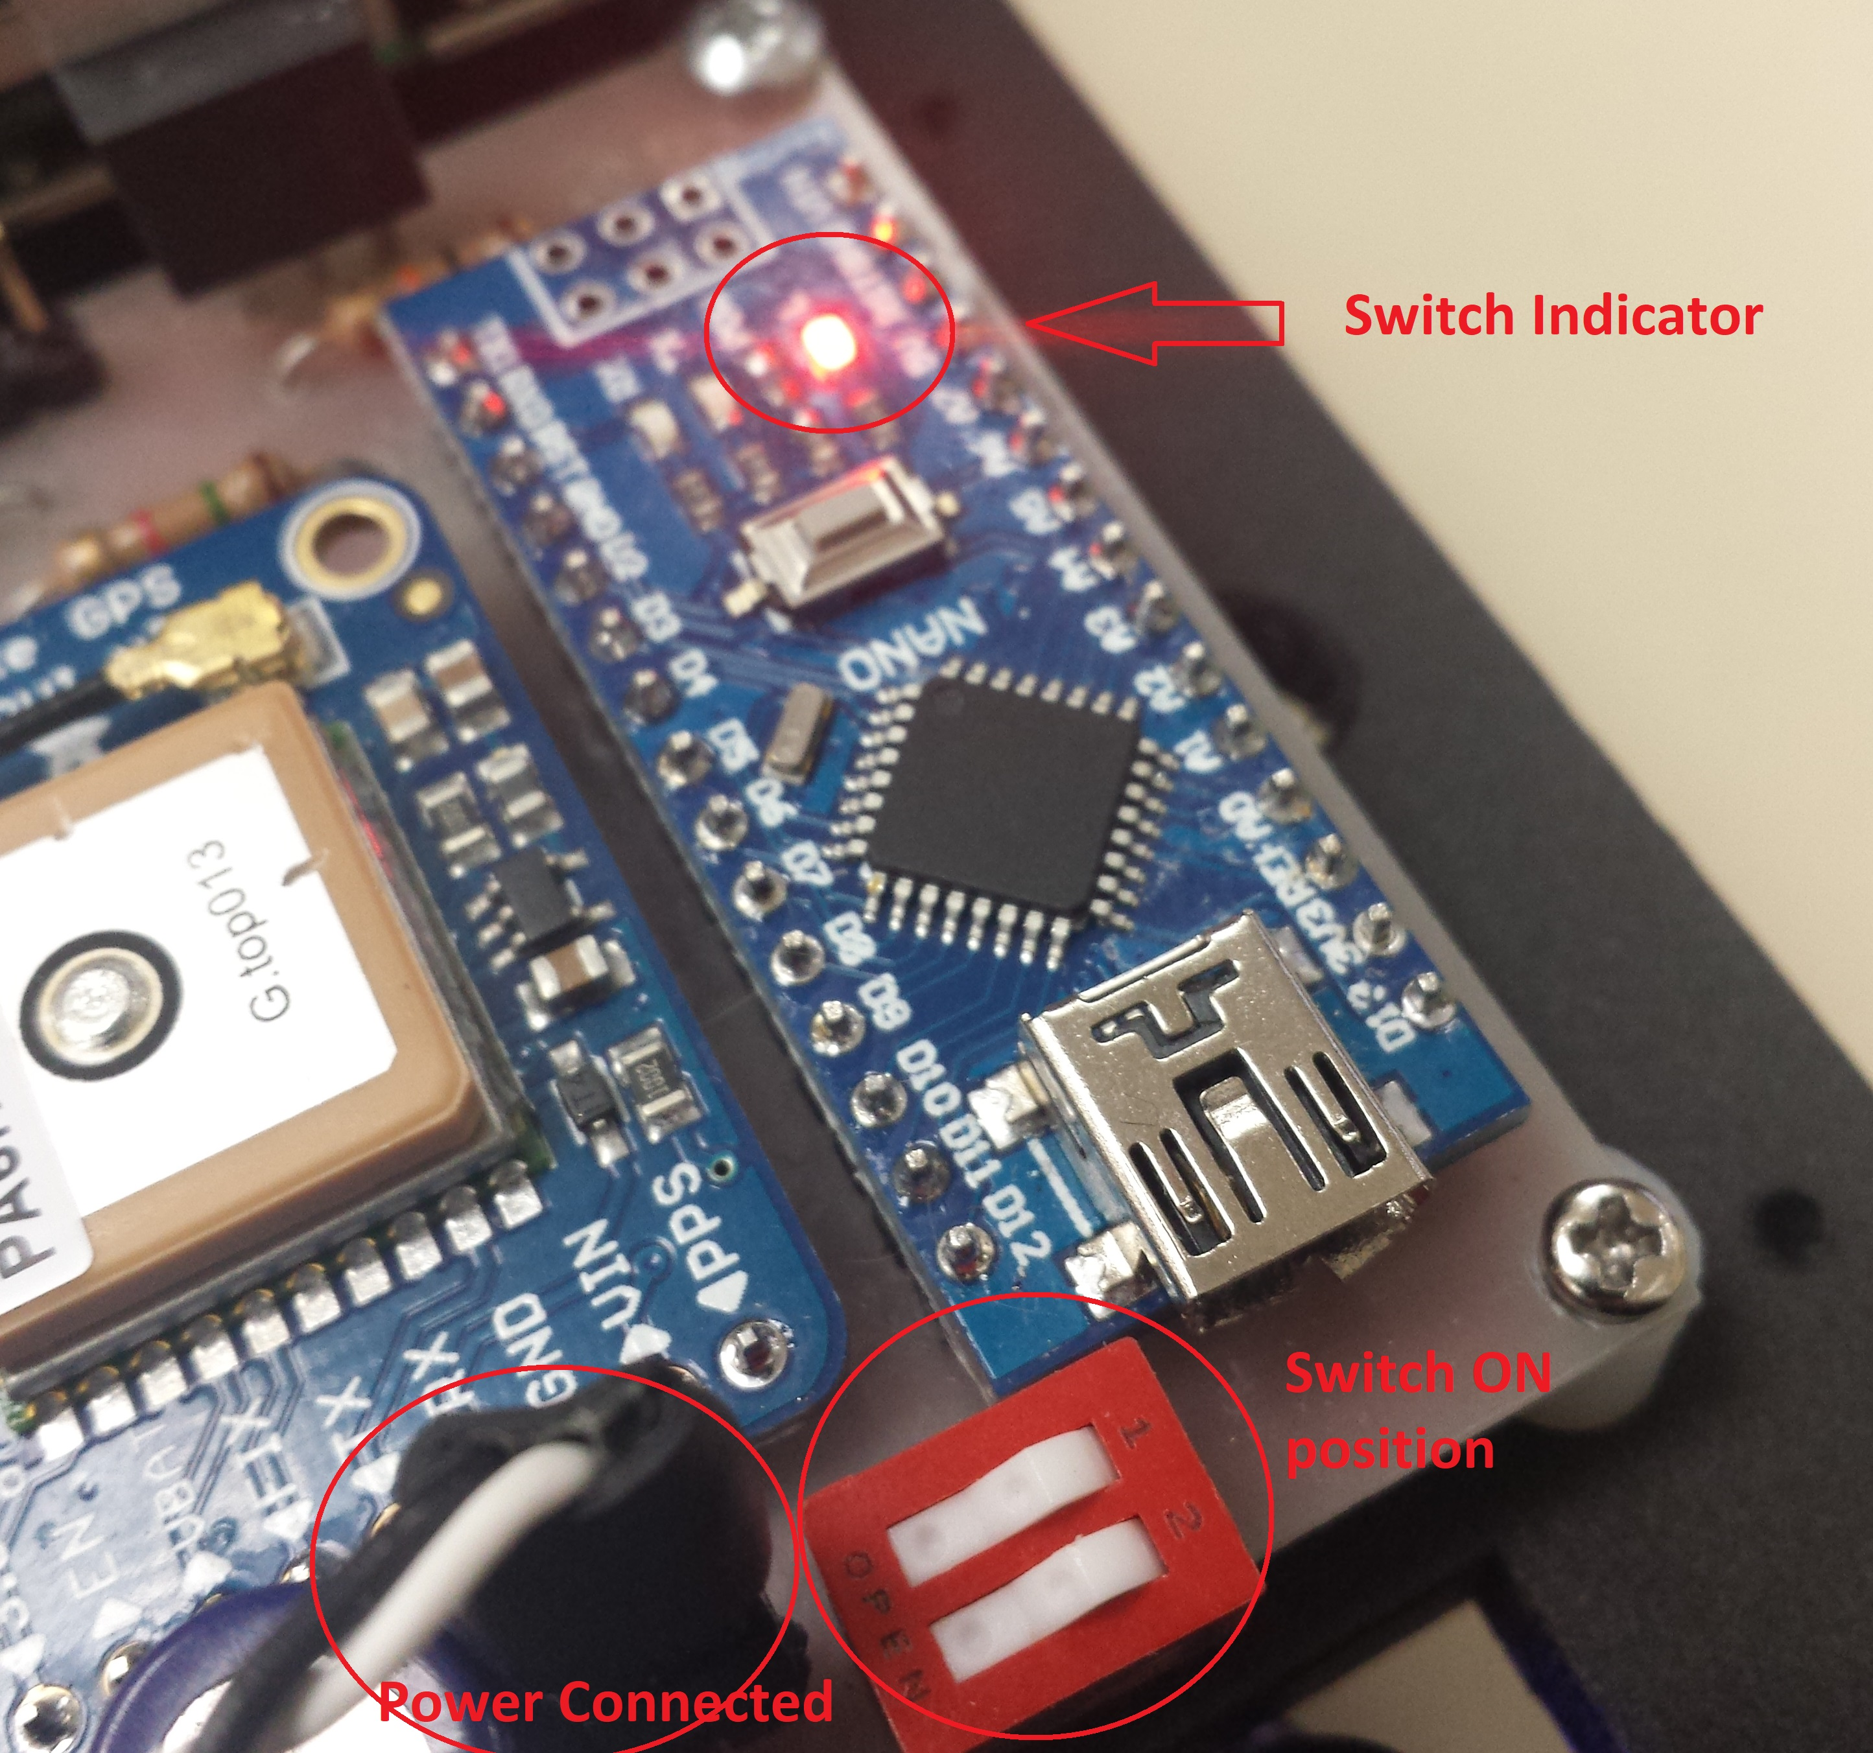

1. **Verify camera board power up** – Make sure Blue Timing controller (Arduino) is connected to the Raspberry Pi via 5 pin connector. When the switch turned on, the main raspberry pi controller will boot up and go thought its starting routine. Make sure Red (power) and Green (activity) LED’s are on and flashing.  
   Note: if switch is turned on before “start” time, the camera board will boot up (usually takes few minutes) read the file and shutdown right away, until the proper start time.

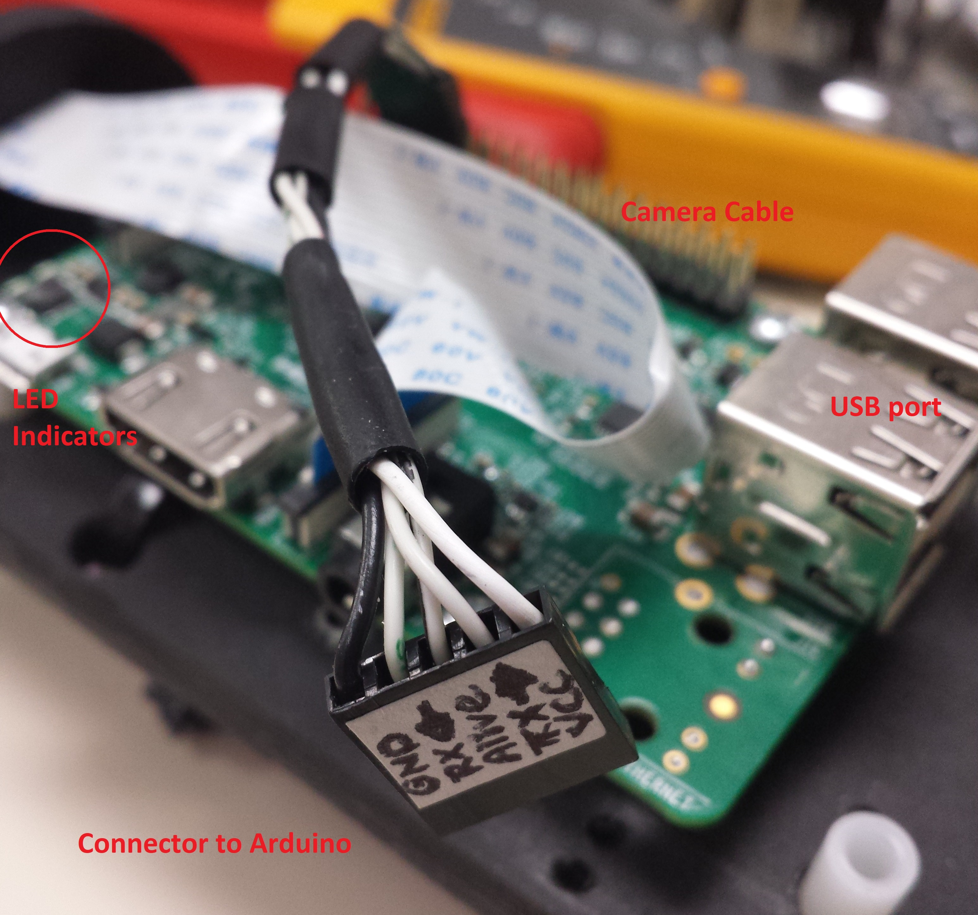

End of deployment:

* Carefully remove camera from the housing, without disconnecting any connectors.
* Observe status LED’s on the Green Camera Controller (Raspberry Pi), If Red LED is on and Green is flashing, Camera is still recording.
* Turn the Red **switch** on Blue board to **OFF** position and wait for a few minutes, this will send a shutdown command for Raspberry Pi controller to end video and properly close the file
* When both LED are off, the USB drive can be removed and from the port and power connector disconnected.

Output:

At the end of each mission, USB drive will contain three new files:

* **Video recording** – Video recording will be named with a timestamp in the following form: YYYY-MM-DD_hh_mm_ss. Video format is **.h264** and need to be converted into mp4 or other formats.
* **GPS data** – data is written in a spreadsheet compatible file – CSV. Name of the file is a timestamp with the following format YYYY-MM-DD.
* **Troubleshooting log** – log file called **turtle.log** has information about system performance for all previous deployments. It is useful for developers to troubleshoot the software and find faults.

All the file mentioned above can be copied and deleted from the drive, **mission.txt** file however, needs to be present across all deployments.

For more information contact:

Arthur Bondar

E: [arthur.bondar@gmail.com](mailto:arthur.bondar@gmail.com)

T: (780) 729-8618